

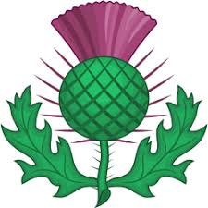

BRANCH NEWS MAY 2020
Registered charity No. 1069188

UNPRECEDENTED TIMES

Literally before the ink was dry on the Listings in the March Newsletter (containing 17 events taking place in or near South Wales between March and June) it began to dawn on us all that this had already become a work of fiction. It’s heart-breaking to read it through now, and to register all the planned dance events that would have brought us so much pleasure over these months. It will surprise no-one to tell you that, in common with all the other events, the S Wales Festival on 27 June has now been cancelled.
Our Branch AGM, due to take place on 20 June, is also at the least postponed. The Committee are taking advice on the constitutional position in relation to revised dates and time-frames. We are assured that public health considerations override other regulations. It may be possible to hold the 2019-20 AGM in the autumn – but who knows what position we’ll be in by then in terms of lock-down, self-isolating, shielding and social distancing? Or it may be feasible to confine this year to audited accounts, and to hold everything else over to next year. Or what about AGM by Skype or Zoom? As soon as we have greater clarity we’ll let you know.
As you’re aware, at the end of 2019 we lost one of our members. We paid tribute to Kate Gray in our last issue. Sadly, since then we have lost two more of our S Wales dancers. Mary Robertson, a longstanding and very faithful stalwart of the Branch, died in a care home on 3 April (mercifully, not of coronavirus). A tribute to Mary features below.
However I’m afraid that it was Covid-19 (and pre-existing medical problems) which robbed us of another dancer, Heather Tough, in hospital on 22 April. Heather and Graham had also been longstanding Branch members who regularly danced with a number of local groups (and also with Scottish groups when they were at their home in Perthshire). Graham continued to be a member for a number of years after Heather had reduced her dancing, and although he subsequently left the Branch for a year or two he tells us that he now intends to re-join us. I’m sure we would all wish to express condolences to Graham on his sad loss.

I thought members might be interested in an article brought to my attention by Maureen in Cardiff. This appeared in the February 2020 issue of the “Third Age Matters” magazine, the publication of the University of the Third Age (U3A). Most of you will recognise the name of the author, Mervyn Short, a distinguished SCD teacher who lives in Hampshire and who has been very active in the Society, including a period as Deputy Director of Summer School in St Andrews. He is much sought after as a teacher at day schools and residential weekends, and indeed many years ago he taught one of our S Wales Day Schools. Mervyn has since developed an international reputation as a dancer and teacher. His warm-ups are legendary!

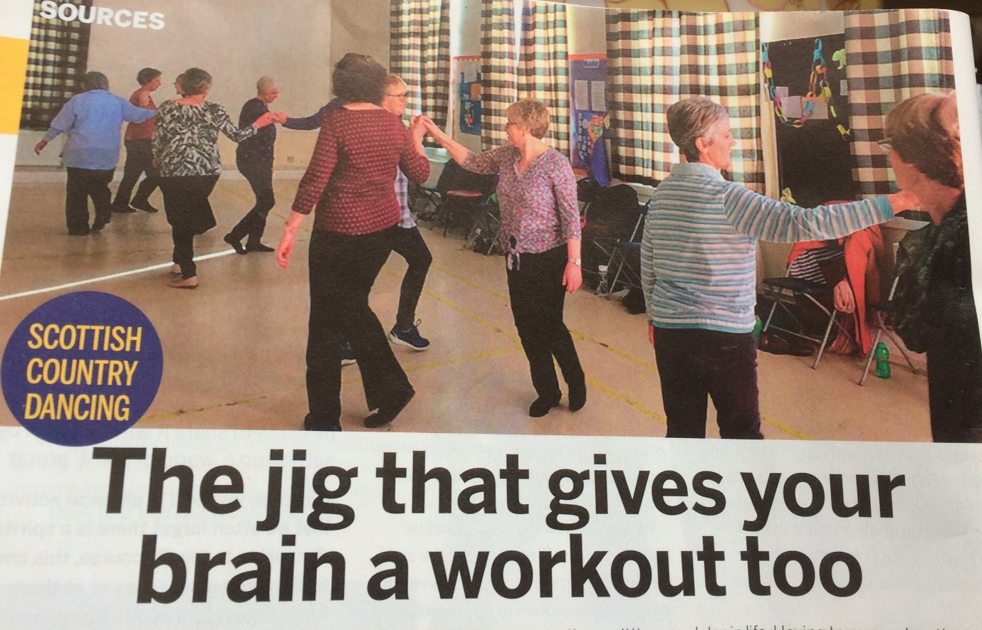
MERVYN’S ARTICLE IN “THIRD AGE MATTERS”, FEBRUARY 2020
I have been dancing for about 30 years, writes University of the Third Age (U3A) national advisor for Scottish country dancing, Mervyn Short.
I began in my late 20s after starting a sedentary office job with long hours. I knew I needed to do some exercise and, remembering I had enjoyed the Scottish dancing we had occasionally done at school, found a nearby group. Over time, I have met people from all over the word through Scottish country dancing: it is amazing the countries it has spread to.
Although Scottish dancing is energetic, it is done in relatively short bursts. Most jigs and reels last less than five minutes and the strathspeys just over eight, so it is possible to rest between dances or sit out one or two if needed.
In many dances you are not moving the whole time, so there are moments to get your breath back. The music is very lively and toe-tapping. Even those sitting it out find themselves clapping along, and the slower strathspeys are unique to Scottish dancing.
Studies have shown that remembering new formations and different dance tempos creates new neural pathways in the brain – something that more repetitive exercises, though they may be equally good physically, do not do.
A brain with a more complex and varied neurological network is stronger and may be more resistant to cognitive decline later in life. Having to remember the steps, the formations and the order they come in means you forget everything else. Any problems, worries or stress in your life are forgotten in class and, when everything goes wrong and chaos ensues, the laughter is an equally good tonic.
Sociability is really important. A lot of people will be alone. Those who come with a friend or as a couple need to mix, so I always announce a new dance by saying: “Find a partner, someone you haven’t danced with today”.
I once had to quietly speak to a couple who always danced together and say: “We don’t stay with the same partner in country dancing.” They then danced with other people and told me afterwards they had enjoyed it a lot more!
So, if there is a group near you, give it a try. It’s great fun and good for you!
Mervyn Short

As it happens, in the same issue of “Third Age Matters” there was also a report about a recent conference on ageing, held in Nottingham by the U3A Network jointly with Nottingham University School of Psychology. The report was headed “Cycling and Dancing Benefit your Brain”.
Among other contributions Psychology Professor Eef Hogervorst of Loughborough School of Sport, Exercise and Health, gave pointers for a lifestyle to limit the risk of dementia, such as a diet based on leafy green foods. He went on to say “Cycling and dancing are better for memory than sudoku, and a mix of strength and stretch exercises works best.”

So here’s to post-lockdown classes, dances – and warm-ups! Don’t give up – we’ll get there!

Isobel Eugene Mary Robertson
(known to us as Mary)
28 June 1926 – 3 April 2020
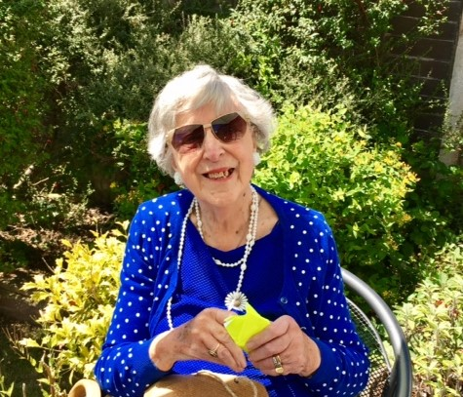
Photo of Mary courtesy of Ian Robertson & Helen Healy
Her daughter Helen refers to Mary as “the special one”. To us too she was very special. In the 1970s and ‘80s Mary and her husband George derived great pleasure from Scottish Country Dancing. After George’s death in 1990 Mary continued to dance, attending classes in Cardiff on a Monday (Caledonian Society) and a Tuesday (Kate Gray’s Radyr Class, now held in Whitchurch). She was also exemplary in her attendance at local dances and at the annual RSCDS Ball, and she was a faithful supporter of the Cardiff Caledonian Society.
Even after she could no longer dance Mary continued to come along to enjoy the dances, the music, and the company (the “fellowship” as she referred to it). She came and sat with us as a spectator during classes and social dances over several years, virtually without fail, through heatwaves and freeze-ups. (I still have “Mary’s blanket” folded up ready for her, and I know that Carol still has her hot water bottle.) One class member has referred to her as a “palpable presence” even after September 2018, when she became hospitalised and subsequently housebound.
We used to love the way in which right to the end Mary would always put on her dance pumps at the start of a class (or, latterly, have one of us kneeling at her feet to put them on for her!). She did the warm-up exercises from her chair, and class members used to help her to her feet to join our circle for the final cool-down. “Indomitable spirit” has been used by more than one class member in their memories of her. And without exception, dancers have commented on how uncomplaining she was, never self-absorbed, always interested in others.
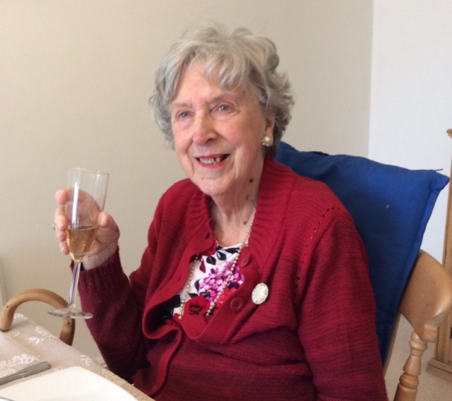
Photo of Mary courtesy of Ian Robertson & Helen Healy
I shall leave it to those others to sum up this very special person for us. In response to my e-mail announcing the sad news of her death I received a deluge of lovely tributes. Here are a few of those:
Mary’s determination to keep her active life going was remarkable, especially when you remember how ill she was, and for how long – and how often she was in and out of hospital. […] She was notably unselfpitying, and much more interested in what others were doing than in talking about herself. It was noticeable that, while sitting, she moved her feet in time to the music; and she always arranged to get her dancing shoes on!
She was a great character and never complained about her circumstances. Instead she was always interested in you and your family and she always enjoyed a chat on the phone or better still a visit. I will miss her strength and spirit and she will be missed by her family. She is in my prayers.
Aww that is sad news, glad she was comforted at the end.
Although I didn't know her for very long I felt, right from the start, the warmth of her friendly, caring personality. It was always a pleasure to chat to her and a privilege to be able to help her when she joined in the cool down at the end of class. I shall remember her with great affection
I am glad dear Mary’s time in the nursing home was short, as she so preferred being at home. Sad to lose the example of her indomitable spirit.
I am so saddened by your news, Mary's attendance and conversation was always something to look forward to. Please God, when this pandemic is over, I can come back and dance Robertson Rant.

To conclude, perhaps I need to explain one or two references above, and to give a little bit of a look ahead. In February, only about six weeks before she died, Mary moved into a care home. Although the Covid-19 lockdown was already in force her son Ian and daughter Helen were allowed to visit her briefly at the end.
It has been suggested that when we – eventually – return to classes and dances we should put “Robertson Rant” on our first programmes in order to pay our respects to Mary. The family are also planning a memorial service in Llandaff Cathedral. At present this is due to take place on Saturday 26 September at 2:00 pm, but this may yet need to change, depending on our progress out of lockdown.
Helen and Ian have been very touched by all the lovely comments from dancers, and indeed have wished to stress the importance of Scottish Country Dancing as a source of great joy to their mother. Helen has sent me a number of photographs. A batch of these delightfully illustrate Mary’s irrepressible sense of fun. I also have a link to a five-minute video of the very beautiful and dignified private burial ceremony on 20 April at the family grave in Cathays Cemetery. If anyone would like to see these, please let me know. Helen and Ian have also asked whether any of us might have photos of their mother at SCD events – if so, likewise please get in touch.
Helen told me recently how much she will always miss her mother’s “kind and loving ways”. We will too – especially as we may all need more of these right now.
Alison Jackson
I had almost completed this Newsletter when I received a fascinating write-up (along with the attached photograph of Mary and George dancing together) from Ian, Mary’s son. It is such an interesting account of Mary’s dancing years that I felt I needed to include it in full.
Our mother’s journey to and passion for Scottish Country Dancing
Mary Robertson’s maiden name was Fenwick, and she was always aware of her Scottish heritage. She met George William Robertson, a New Zealander who had served in the NZ Merchant Navy, at the end of the 1940s. His upbringing gave him a strong Scottish background, his grandparents having resettled from Ayrshire to the South Island, near Dunedin.
He had decided to make a new life in the UK and found himself in Cardiff. He and Mary were married in 1953 at Llandaff Cathedral. Throughout their courtship and early married days they were keen and competent dancers, mostly ballroom based.

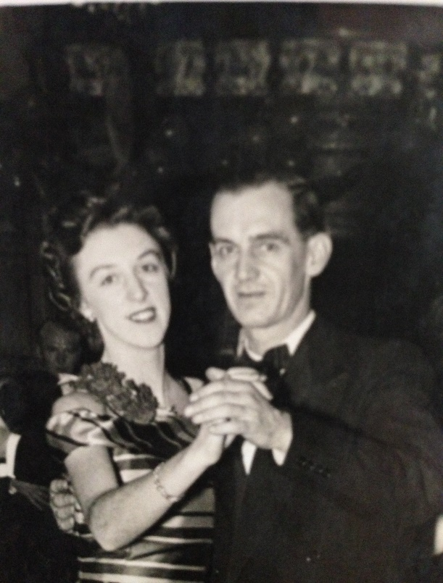
Mary & George Robertson - photo courtesy of Ian & Helen
George had developed strong friendships at Windsor Place Presbyterian Church (now the City United Reformed Church) in the centre of Cardiff and felt amongst friends, most of whom had Scottish origins. Most church socials at the time were based on Scottish celebrations and were always family occasions.
Once their children Ian and Helen were old enough and more independent Mary and George took more of an interest in their Scottish links. They became members of the Cardiff RSCDS at the time of Tom and Jean Leggatt and then of Kate and Alex Gray. As their interest and competence grew they attended some of the RSCDS Summer Schools at St Andrews.
George, who had become the Session Clerk at Windsor Place Church, was an excellent keyboard musician and played a mean piano accordion. After one occasion when he had struggled to book a Scottish band for a Burns Night in the early 1970s, he formed a Scottish Country Dance Band known as The Thistles and they began to play at ceilidhs, Burns Nights, Hogmanay celebrations etc. They played for about ten years and thoroughly entertained everyone at their performances.
George’s ill health in the late 1980s meant that they were not able to be active dance participants, but they always kept in touch with the friends they had made. They kept their RSCDS membership and interest alive. Following George’s passing in 1990 Mary renewed her interest in all aspects of the life that she had foregone, and Scottish Dancing was back on her agenda.
Scottish and other forms of dancing featured one way or another for the next 30 years when despite Mary’s failing health she would regularly attend weekly dances, tapping her feet in time to the music whilst catching up with everyone’s news. Her friends made her very welcome, even providing hot water bottles and rugs in the cooler months. She loved this contact and until her recent passing she was visited by and corresponded with by many of her SCD friends. She loved the friendship and kindness of all of her lovely friends at the RSCDS and so enjoyed being part of the group for as long as she could.
Mary’s family really appreciate all that Scottish Country Dancing brought to her and their Dad’s lives, enriching and stimulating them not just through the dancing itself but through the music and camaraderie.
Ian Robertson


Dance Scottish at Home
During those strange times when we can’t meet to dance, the RSCDS is working very hard to keep both our minds and our bodies - and of course, in Miss Milligan’s words, our souls – engaged with Scottish Country Dancing in one form or another.
If you haven’t already done so, have a look at the RSCDS website, where if you go to the “Dance Scottish at Home” you can find all sorts of treasures – blogs, articles of historical and musical interest, recordings, puzzles – and a weekly on-line dance class. These goodies are available to all – you don’t have to be a member of the RSCDS. So tell all your non-member friends – but encourage them to join too, as this is just one of the many ways in which the Society works hard to support SCD for all of us, and without membership subscriptions all these activities wouldn’t happen …. well, you all know this, of course! But spread the word!
As far as the on-line dance class is concerned, I’d encourage everyone who is badly missing their weekly classes to have a look. It’s every Wednesday, from 7:00 until 7:30 pm, and is currently attracting over 1200 participants from all around the world. Those in other time-zones who have to get up at the crack of dawn to take part in the live broadcast deserve special commendation. (Though it is recorded, so you can catch up at any time.)
Anyway, it’s run by a different teacher each week. So far we’ve had Angela Young in Perthshire doing some step practice, Mervyn Short in Hampshire getting us to take part in some of his famous warm-up routines (see previous article), David Hall in Vienna teaching us “The Lea Rig” and Diana Hastie in Sydney covering some Scottish step dancing. And just to reassure you – even if you take part in the live class, your camera and microphone are automatically turned off, so on-one else can see or hear you. “Just as well” is the heartfelt cry from many of us!!!
It’s been good fun so far, and makes for a high point in the week!

BRANCH CONTACT DETAILS
Chair: Conor Farmer, tel 07812 569744 conorfarmer52@googlemail.com
Secretary: Alison Jackson, tel. 07811 082510 jacksonaj@talktalk.net
Treasurer: Pat Rye, tel. 01646 698463 ryedp@hotmail.com
Website Manager: Fran Smith fran@rscds-southwales.org.uk

www.rscds-southwales.org.uk

